We can use the bycle model to represent how a car moves.

Here are the assumptions that go with this model.

We will ignore all vertical dynamics of the car, so only 2D motion.

Like a bike we assume the front and back tires are connected like a rigid body.

We also assume that the front left and front right wheels move the exact same, so they can be modeled as one wheel in the center of the vehicle.

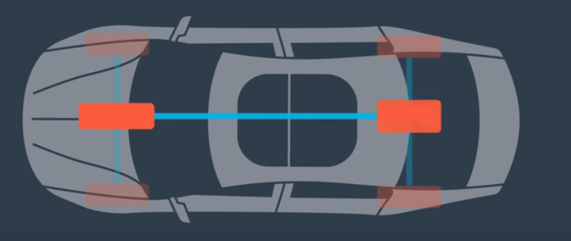

We also say the tires angle relative to the front of the vehicle is theta.

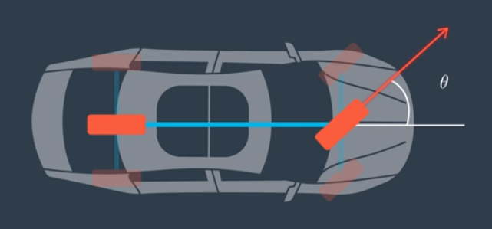

**Yaw is the cars heading** or orientation of the vehicle. The angle is relative to the x axis.

Counter clockwise angles are considered positive.

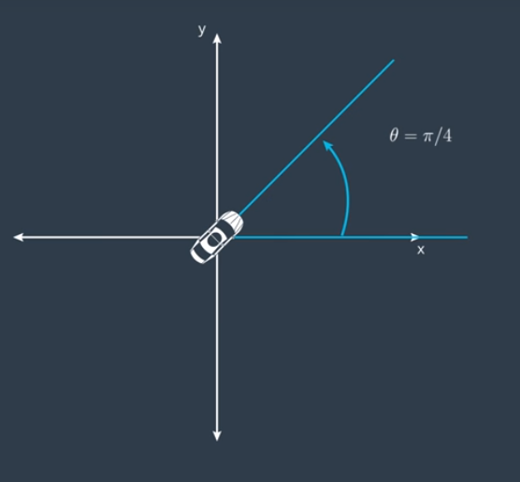

Under the assumptions of constant turn rate (yaw dot) and velocity, or zero angular accleration and acceleration.

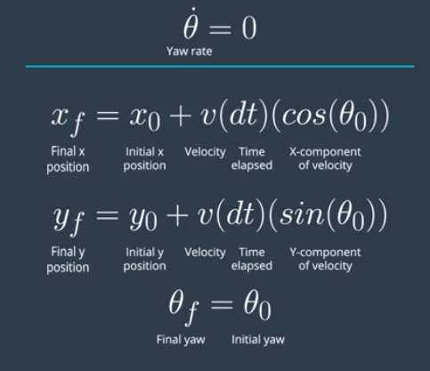

With the yaw rate not equal to zero.

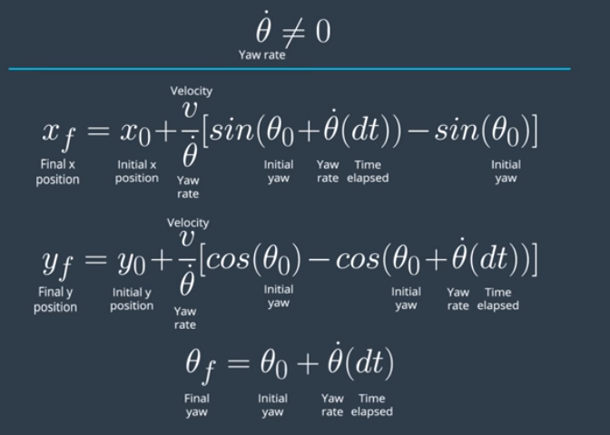

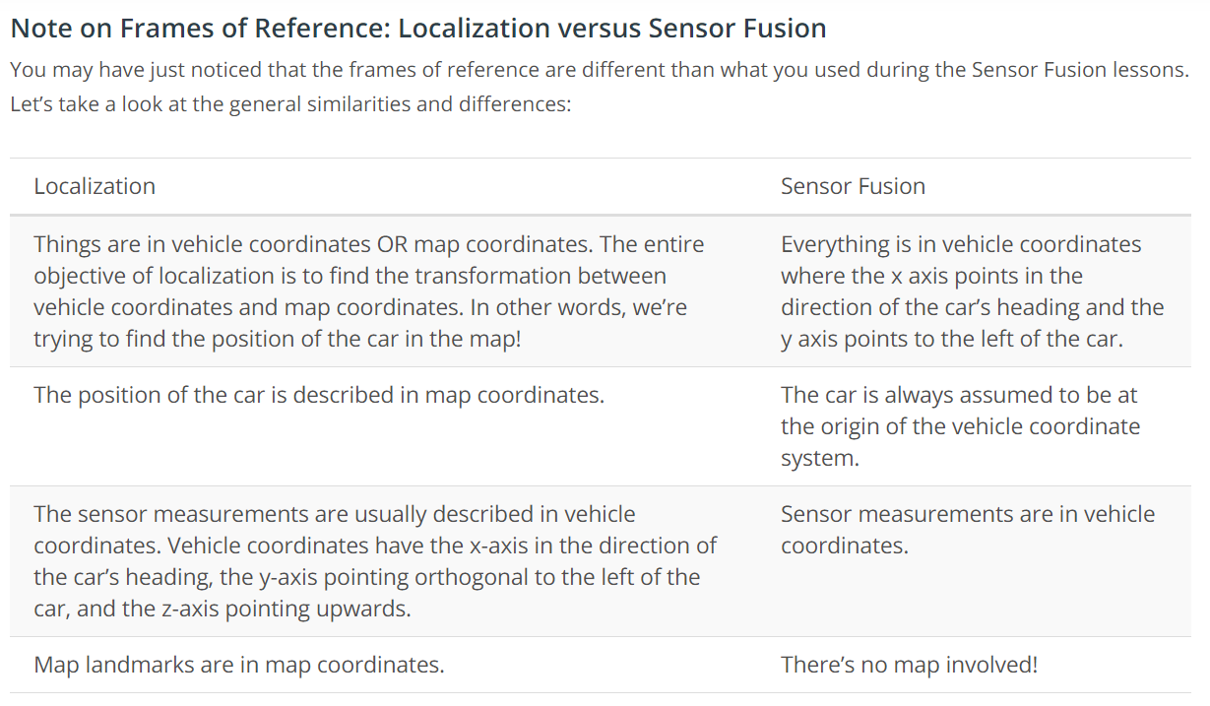

Roll, Pitch and Yaw are the rotations about x, y, and z axis respectively. Are all 3 angle calculations necessary? It depends on the location.

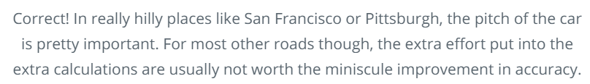

**Odometry**

Odometry is another common method to calculate the cars new position.

It is the use of data from motion sensors to estimate the change in position over time.

Wheel sensors measure the amount of times a wheel has turned, and uses the wheels circumference to calculate the distance traveled.

Odometry is great for roads with a lot of turns.

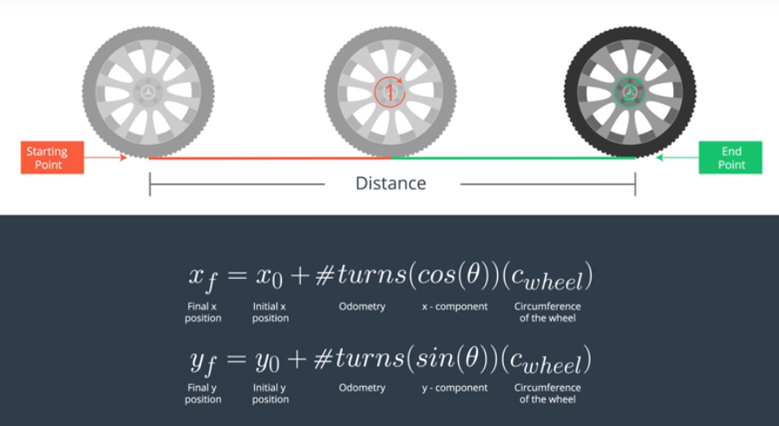

**When is Odometry wrong?**

On a slick, wet road. (Wheel slipping causes them to calculate a smaller distance than expected)

And On a road with lots of bumps. (A lot of the distance the wheel covers is vertical and not horizontal)

